** Hawes Primary School**

**Assessment Policy**

Our Hawes Primary School/YCAT assessment policy is based on a research review of the most effective assessment approaches and identifies the best ways to use assessment for the implementation of a high-quality curriculum that ensures pupils know more, remember more and develop fluency.

Key principles that inform our assessment policy are:

**purpose**

**validity**

**reliability**

**value**

Our belief is that assessment permeates all aspects of a quality first curriculum; pupils’ progress is an alteration to long term memory and is more than test results and progress scores. We will only have impact on pupils’ learning if we have practical approaches and systems that continuously focus on securing and deepening all groups of pupils’ learning.

**How assessment operates in our school**

* **Formative assessment through continuous feedback** (AFL or assessment for learning) is at the heart of our assessment and is the golden thread across the school’s curriculum that ensures all children receive a high-quality education. This is continuous feedback during all lessons between pupil and teacher that quickly identifies if a child is not keeping up with their curriculum endpoints (the key learning to achieve by the end of a lesson, unit of work or school year, as identified on our curriculum progression documents for each subject). This feedback enables teachers to quickly provide either adaptations, additional support or extra practice, particularly for the lowest 20% and SEND pupils. Formative assessment (AFL) feedback is used by the teacher to make sure the planned curriculum is in the right order and focuses on small steps that builds knowledge systematically and cumulatively through the school. Talk for learning and talk about how we learn and remember is an integral part of our formative assessment. We follow the EEF **'Six recommendations for using teacher feedback to improve pupils learning’, June 2021** to inform and support our feedback:

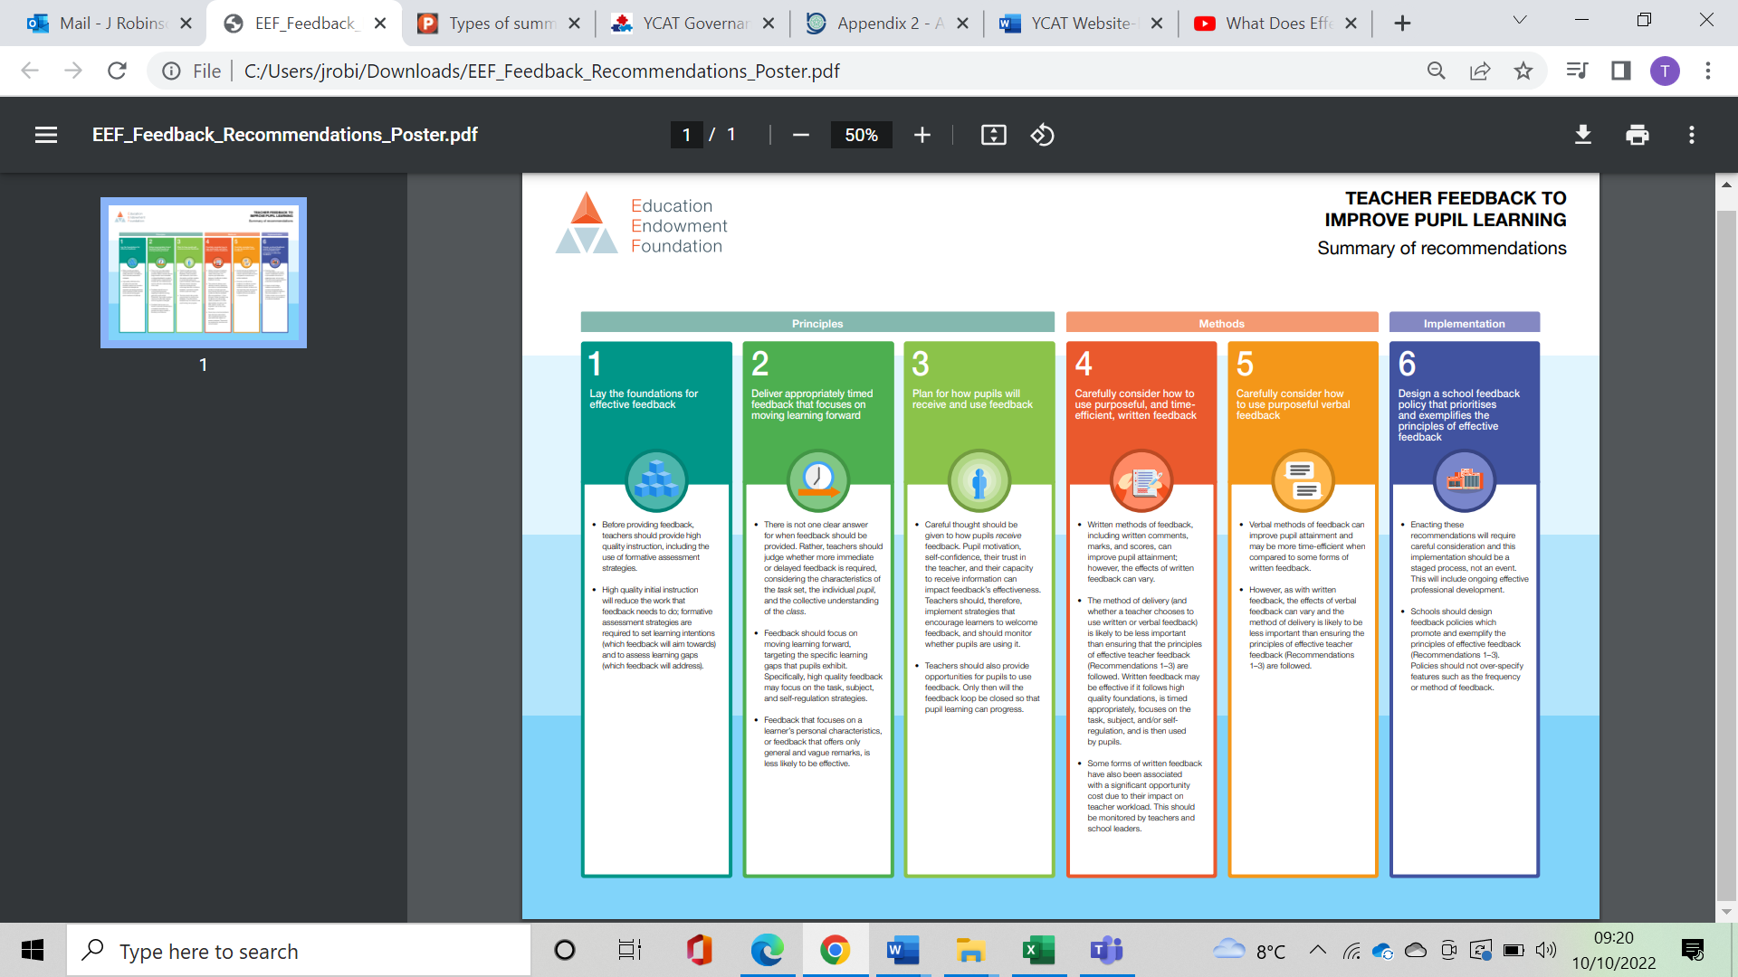

* Our first step is always **identifying gaps in pupils’ knowledge and skills before they begin new units of work**. This is through:
* knowledge check assessments at the start of every new unit of work across the curriculum to identify specific gaps in knowledge. We use low stakes quizzes, not standardised tests, for these checks
* at the start of each school year, checks of essential knowledge in our core subjects of English and Maths from the previous year’s work, before starting the new school year’s cumulative curriculum
* in English, we focus on checking and embedding the previous year’s essential knowledge (we call this our connected knowledge) for Writing, including grammar, punctuation and spelling, through assessment and learning across the whole of the Autumn Term.
* **New learning acquisition is checked** regularly **during each unit of work** through lesson starter recaps, mini knowledge checks and plenaries, as well as via continuous feedback/AFL. An **end of unit assessment**, which is usually one or more lesson activities planned to demonstrate how far pupils have met the identified key endpoints for learning takes place at the end of each unit of work. Simple **assessment summary record sheets** are used for each unit of work; these avoid excessive teacher workload through focus on the key endpoints (taken from our curriculum progression documents) and noting only those pupils who either have not achieved endpoints (with clear information on which ones) and those who have achieved at greater depth beyond the expected endpoints.
* Pupils’ progress is an alteration to long term memory and we further check and support pupils to remember all subject end points by **spaced assessment recall activities and quizzes** at 2, 6 and 12 weeks following the teaching of each unit of work. These low stakes assessments ensure teachers and pupils know that the intended taught curriculum has been remembered in core and foundation subjects. The quizzes are kept in pupils’ books; teachers use the information from them to address gaps and plan for future teaching; they pass on information about children not secure in remembering their end points to the pupils’ next teacher, via notes on the summary record sheets for each unit (see above).
* **Summative assessments** are also used in English and Maths to validate standards and provide further information about pupil progress made across the core subjects by **the end of each term**. These take place in a termly assessment week and include standardized tests (National SATs papers/tests, White Rose Maths end of term/unit assessments, NFER Reading tests), reading and writing assessment tasks. Results and planned next steps are shared in detail for each pupil in 1-1 pupil progress discussions between class teachers and leaders, recorded on our core subject tracking system and reported at year group and subject level to all staff and governors as part of our accountability, evaluation and target-setting processes.
* We complete **nationally-reported statutory assessments** annually for EYFS (start of Autumn Term Reception Baseline), Y1 Phonics Screening test, end of KS1 (Y2) teacher assessments judged against the Y2 TA frameworks, Y4 Multiplication Tables Check and end of KS2 tests (Y6 SATs). These are used to understand pupil achievement against national expectations and comparisons and results are reported to parents, governors and the LA/DfE, as well as moderated externally.
* Termly **moderation of writing** through internal staff meetings, shared work with YCAT/other schools and via the LA further ensures and assures the reliability and validity of our assessment of writing.
* **Regular monitoring of the curriculum by leaders (including governors) and subject leaders/teachers** further assures the reliability of assessment throughout the school and is in line with **our curriculum policy: everyone leads Hawes’ curriculum**. It both checks and ensures pupils know and remember their specific taught curriculum and that they develop greater fluency as they move through the school. This includes **planning scrutiny, lesson drop-ins, workbook scrutiny (including via staff meetings) and pupil voice discussion groups with their work.** These checks are supported and workload reduced by use of monitoring record sheets for each activity, which include key focus on: whether learning happens in the right order, at the right time and with the most appropriate pedagogy for pupils and subjects; pupils’ ability to “draw on” previous learning and connect knowledge across the curriculum; pupils’ ability to explicitly use the language of learning, remember their intended curriculum end points and achieve fluency with their learning. Monitoring is planned to include all subjects over the year, as set out on our school monitoring schedule, with core subjects monitored at least termly and foundation subjects at least annually. Feedback is shared with staff after each monitoring, including action points, which are revisited at the next monitoring or as needed and inform leaders’ subject/SDP evaluation and next steps for development. All monitoring records are kept in subject leaders’ files and centrally in our ‘SDP and Monitoring File’ (HT office).
* At the end of each year, as a whole-school team, we will **review the effectiveness of assessment** **and this policy**, considering what is working well? and what could be improved? There is a specific review of assessment for SEND pupils to identify ways to further improve the assessment of small steps within a lesson and across a unit of work.

*AMW, March 2023*